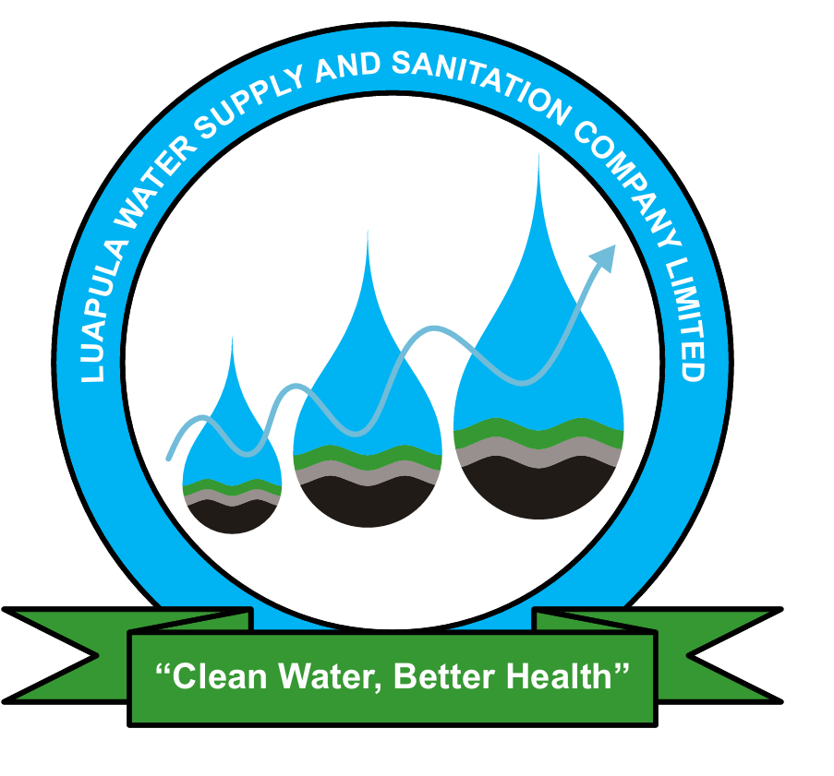
LUAPULA WATER SUPPLY AND SANITATION COMPANY LIMITED
PRESS STATEMENT
(For Immediate Release)

PUBLIC NOTICE FOLLOWING DISCOVERY OF STILL SMALL BABY AT WASTEWATER PUMP STATION

Mansa, Zambia, 23rd December, 2025 – Luapula Water Supply and Sanitation Company Limited (LpWSC) wishes to inform the general public that during routine operations at its Wastewater Pump Station, a Still Small Baby was discovered at the inlet screening point of the sewer system.

Upon discovery, the matter was immediately reported to the relevant law enforcement and health authorities, who have since taken over the matter in line with established legal and investigative procedures. Luapula Water Supply and Sanitation Company Limited is fully cooperating with the authorities on this matter.

LpWSC wishes to clarify and also advise members of the general public that wastewater treatment facilities and sewer networks are designed exclusively for the conveyance of wastewater. The disposal of solid waste, medical waste, biological material, fats, oils, grease, wipes, diapers, hazardous materials, explosive materials, and sharp instruments into the sewer system is strictly prohibited as they are unsafe, unlawful and poses serious public health and environmental risks, in addition to disrupting normal wastewater operations for the public good.

The discovery of the Still Small Baby is regrettable and the Company strongly appeals to members of the public to use sanitation facilities responsibly and to seek appropriate social, medical, legal or community support services when faced with difficult circumstances. The Company urges the public to refrain from speculation and allow the relevant authorities to conduct their investigations.

LpWSC remains committed to safeguarding public health, environmental protection, and the integrity of its sanitation service provision infrastructure.

Further communication will be issued as shall be guided by the responsible authorities.

𝗜𝘀𝘀𝘂𝗲𝗱 𝗯𝘆:
(ORIGINAL SIGNED)

Felix M Katyetye (Mr.)
Public Relations Officer
Luapula Water Supply and Sanitation Company Limited (LpWSC)

For more information contact PRO on: +260960906857
Or Email: fkatyetye@lpwsc.co.zm or info@lpwsc.co.zm

