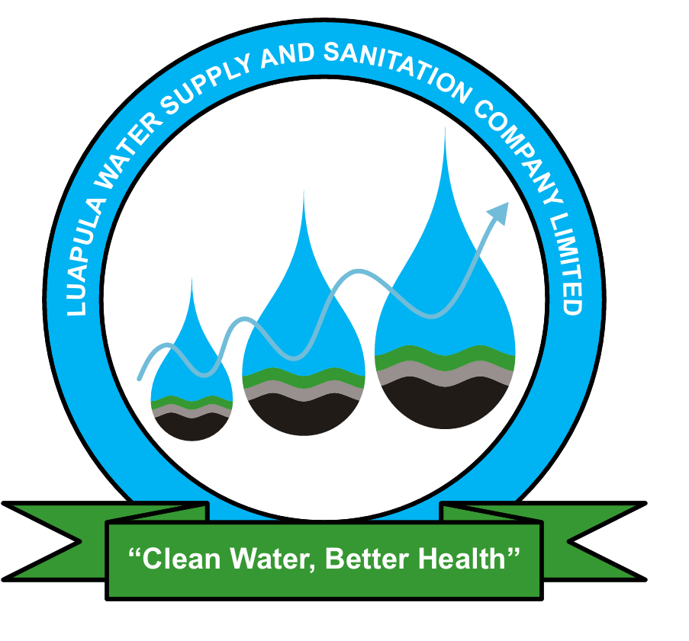
LUAPULA WATER SUPPLY AND SANITATION COMPANY LIMITED
PRESS STATEMENT
(For Immediate Release)

LUAPULA WATER COMMITS TO FIXING THE KAOLE WATER SUPPLY ISSUES

Mansa, Zambia, 24th November, 2025 – The Luapula Water Supply and Sanitation Company Limited (LpWSC) wishes to inform the general public and assure the residents of Kaole, Senama and the surrounding areas in Mansa district that the water supply challenges which have been experienced in the recent past will soon be resolved. The current situation was caused by a combination of three main factors including, the low water levels at our water abstraction point in Mansa district, intermittent power supply from ZESCO and a technical issue with our pumps.

With the onset of the rains, the problem with water resources has been mitigated. However, the other two challenges of power supply and pumping technical issue remain. The Company is actively pursuing various options to find lasting solutions to these problems. Among the pursued interventions on the pumping technical issue, the Company is procuring a New Highlift Pumpset that will be dedicated to pumping water to these affected areas. Customers should expect further stability in water supply to Kaole and the Surrounding Areas within a week hereafter.

The Managing Director, Mr. Mukela Simbuwa, has assured the general public that the Company is pursuing every option available to mitigate the challenge.

“We fully understand and regret the inconvenience caused by the current intermittent water supply to the residents of Kaole and surrounding Areas and want to assure our customers and the general public that we are working around the clock to normalize water supply in these affected areas,” said Mr. Simbuwa.

Meanwhile, LpWSC has collaborated well with the Mansa Municipal Council to deliver water by Bowsers to the affected communities during this time. Though water supply has slightly improved in the past few days, the Company will continue to monitor the situation as it pursues lasting solutions. Customers are encouraged to continue reporting water supply and sanitation issues to the Company through the LpWSC Customer Service Centre using established channels.

The Company also wishes to encourage all customers to continue practicing water conservation by using water wisely, avoiding wastage, and reporting leaks promptly, as responsible use of the supplied water helps ensure that the available water is shared equitably across all communities.

LpWSC wishes to thank you, the customers in Kaole and surrounding Areas, for your patience and understanding during this difficult period and reaffirms its commitment to providing safe, reliable and sustainable water supply and sanitation services to all the people in Luapula.

𝗜𝘀𝘀𝘂𝗲𝗱 𝗯𝘆:
(ORIGINAL SIGNED)

Felix M Katyetye (Mr.)
Public Relations Officer
Luapula Water Supply and Sanitation Company Limited (LpWSC)

For more information contact PRO on: +260960906857
Or Email: fkatyetye@lpwsc.co.zm or info@lpwsc.co.zm

